Activity 4.1.2: Autopsy Report

NOTE: This is only a partial autopsy report. You will be receiving the remainder of the autopsy report in pieces throughout the course.
Office of the Medical Examiner
Metropolitan Government of Anytown
Case # 77
Decedent: Anna Garcia
Age: 38
Weight: 165
Height: 64 Inches
Race: Hispanic
Sex: Female
Date and Time of Autopsy: August 15, 2012 11:00 am
Performed By: Dr. King

Laboratory Results:
Toxicology:
- Blood:
- No evidence of alcohol.
- Evidence of statins, equivalent to 40mg/day. NOTE: A prescription bottle for Vasotec, an ACE inhibitor, was found at the scene, although there is no evidence of this drug in the blood. The decedent most likely had not taken this medication for at least 3-4 days.
- Blood glucose level 280 mg/dL (normal range 70-125 mg/dL)

External Examination
The following X-ray image was obtained of the heart and lungs before internal examination. Lungs appear normal with no infiltrates.

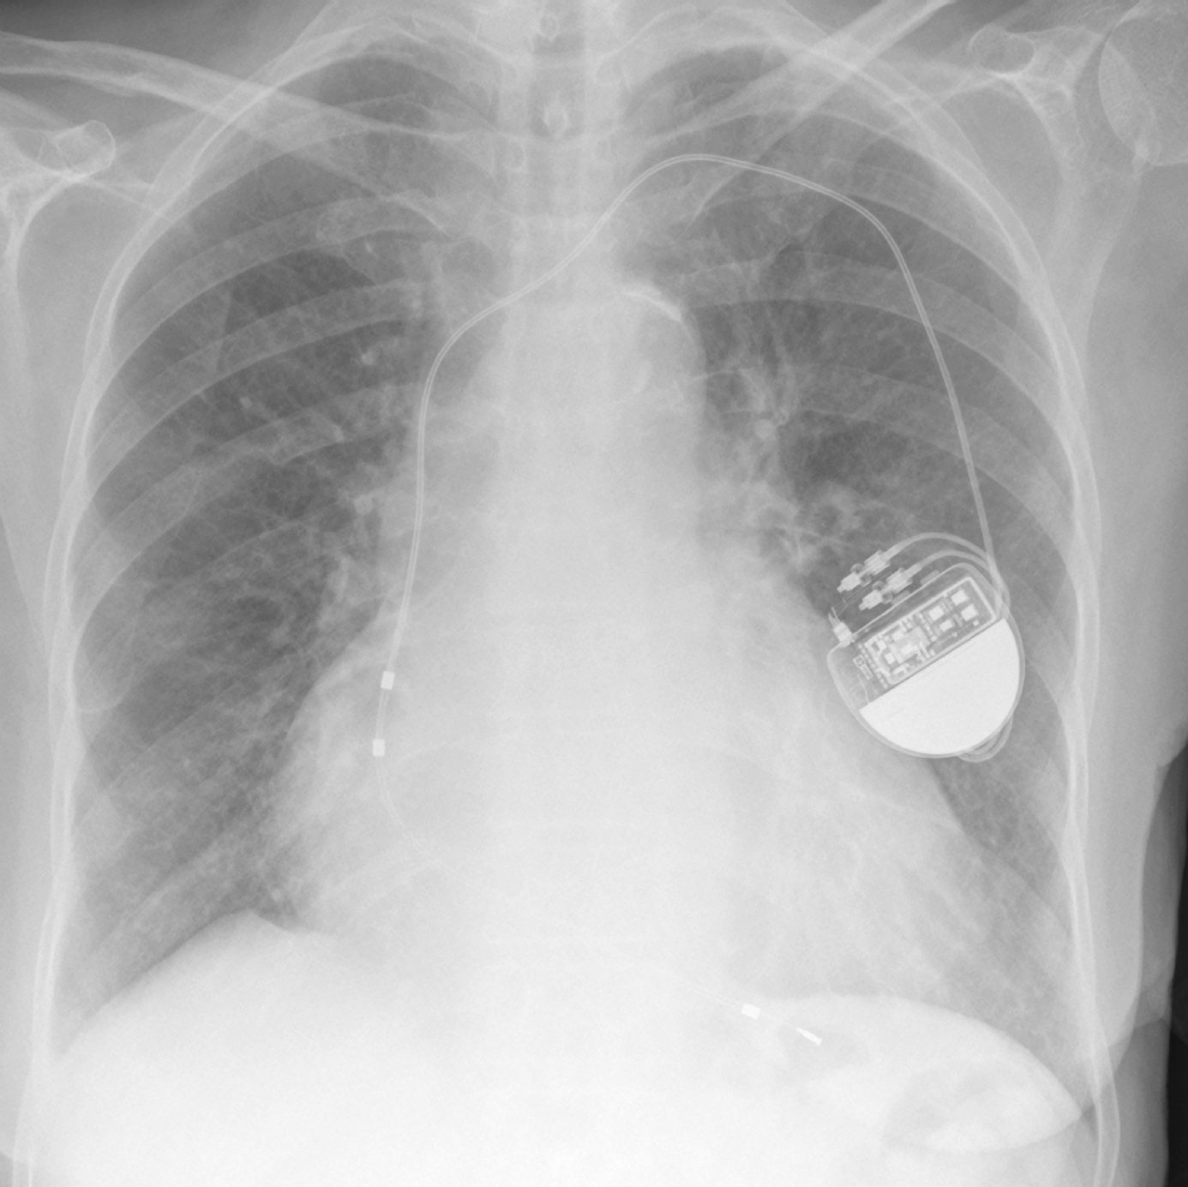
Image courtesy of iStock images

Internal Examination
Cardiovascular System:
Examination of the heart revealed concentric left ventricular hypertrophy. There is also evidence of mild mitral valve prolapse (this means that the mitral valve does not close properly).

Description of left ventricular hypertrophy:

A stent is present in the left anterior descending coronary artery; however, scar tissue and clots partially block or occlude the lumen of the vessel. The right coronary artery is 80% occluded. Narrowing is also noted in the renal arteries as well as the cerebral arteries and provides evidence of atherosclerosis.

Evidence of mild peripheral vascular disease in the left leg.

Possible Causes of Death:

Jane King
_____________________
Jane King, MD
County Medical Examiner

